**Kết quả sau khi training**

**Hình 1**

Looking for faces in 1.jpg

- Found HOBV at (414, 316)

- Found SONNT at (253, 282)

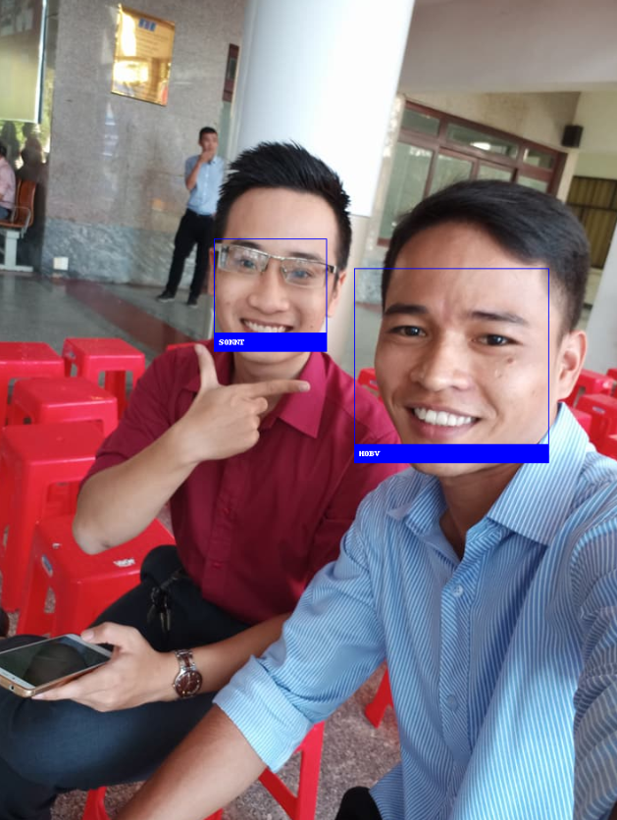

**Hình** 2

Looking for faces in 2.png

- Found HOAI at (602, 290)

- Found PER5 at (249, 262)

- Found PER2 at (46, 437)

- Found PER5 at (385, 238)

- Found PER3 at (973, 270)

- Found TANHT at (832, 425)

- Found HOBV at (429, 271)

- Found PER5 at (625, 246)

- Found PER4 at (905, 250)

- Found PER1 at (469, 320)

- Found TANHT at (175, 262)

- Found PER1 at (493, 214)

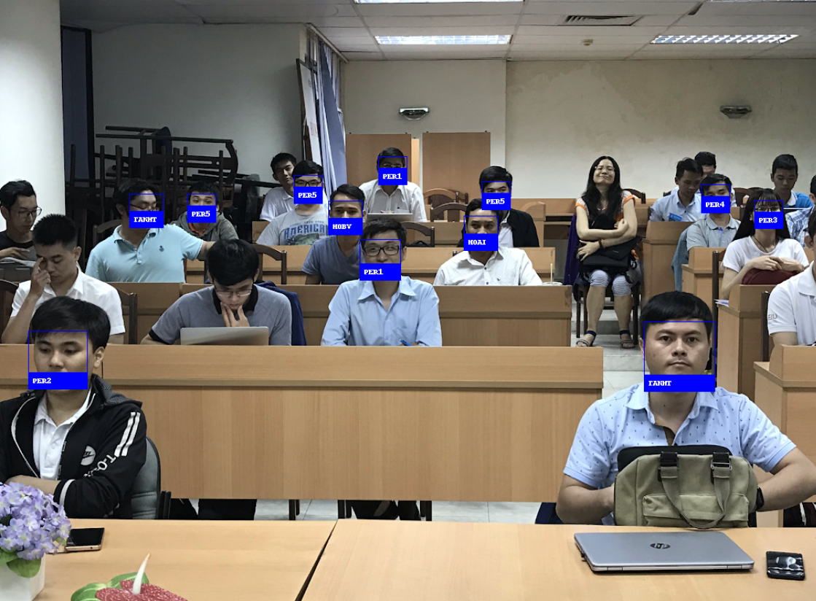

**Hình** 3

Looking for faces in 3.jpg

- Found THAOBT at (992, 184)

- Found TUNGBT at (726, 96)

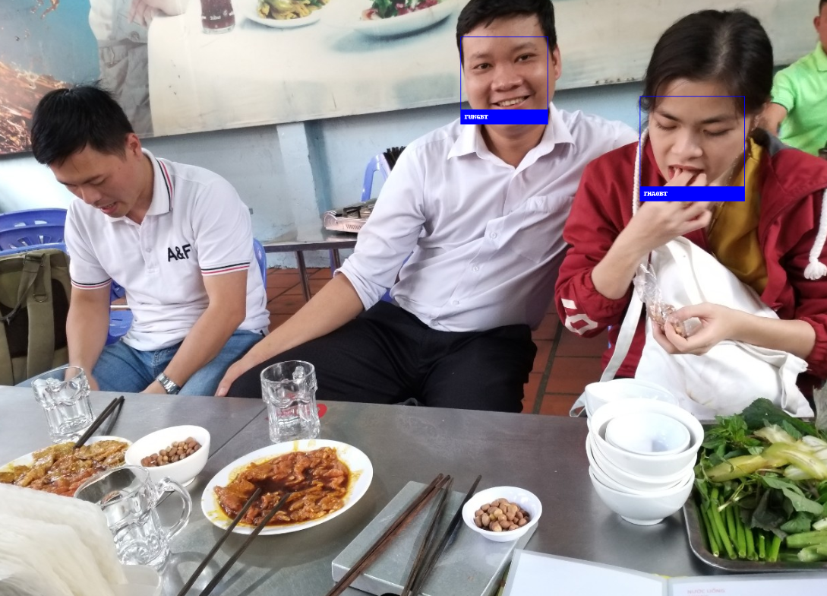

**Hình** 4

Looking for faces in 4.jpg

- Found VYBT at (247, 546)

- Found TUNGBT at (698, 468)

- Found PER1 at (609, 470)

- Found TANHT at (419, 495)

- Found HOBV at (521, 470)

- Found HOBV at (956, 540)

- Found PER1 at (469, 452)

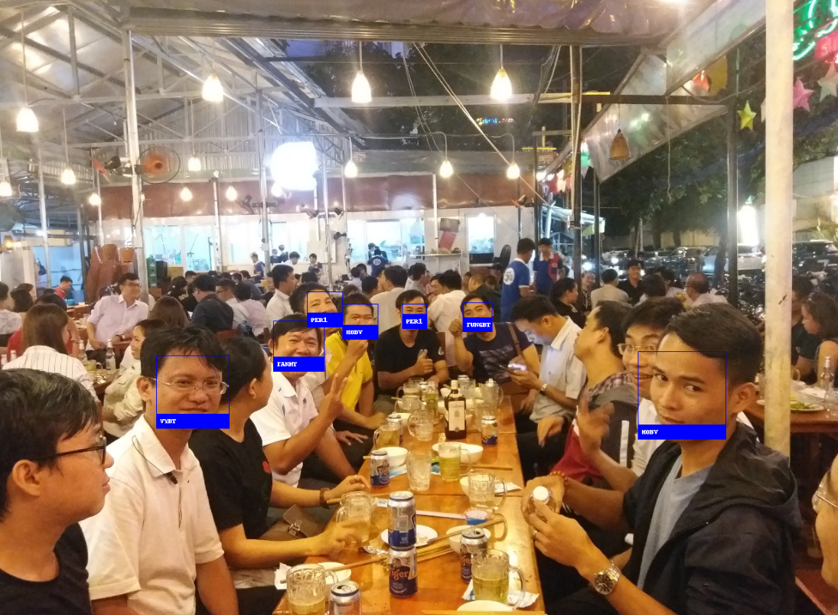

**Hình** 5

Looking for faces in 5.jpg

- Found TRAMBT at (748, 271)

- Found THAOBT at (643, 271)

- Found HOAI at (552, 204)

- Found OBAMA at (386, 199)

- Found TAIHPT at (91, 235)

- Found TUNGBT at (481, 228)

- Found unknown at (279, 216)

- Found TAIHPT at (233, 205)

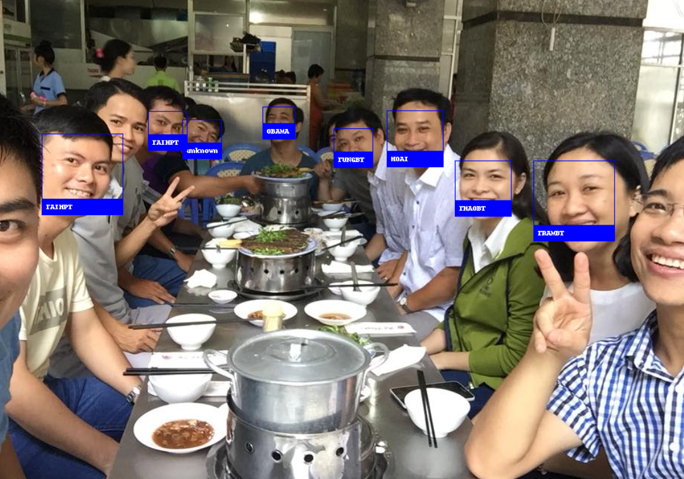

**Hình** 6

Looking for faces in 6.jpg

- Found TAIHPT at (655, 366)

- Found VYBT at (943, 142)

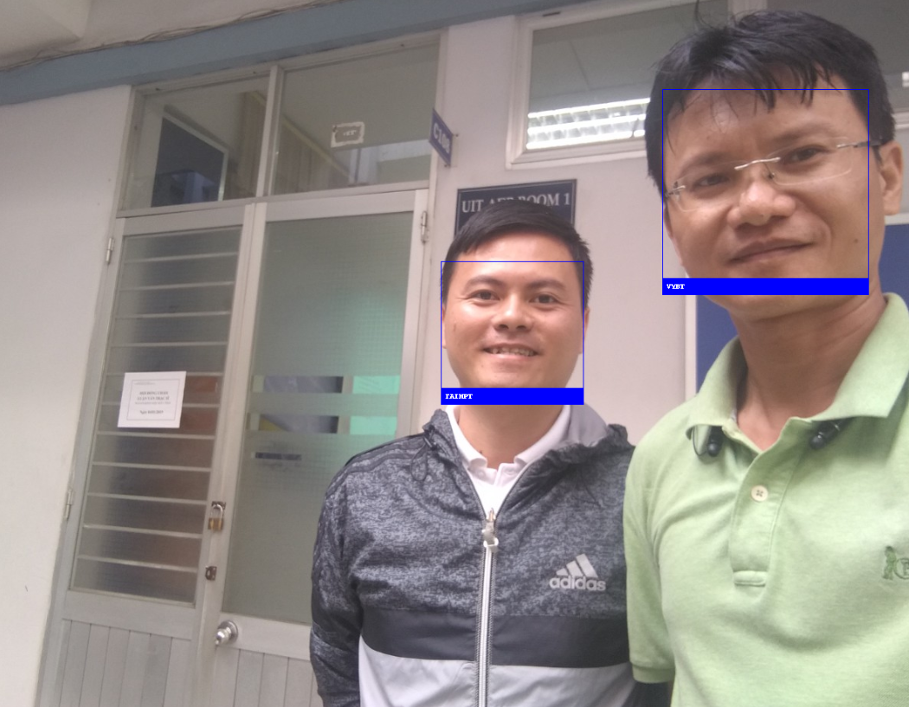

**Hình** 7

Looking for faces in 7.jpg

- Found BIDEN at (778, 57)

- Found OBAMA at (253, 47)

